Ideation Phase
Brainstorm & Idea Prioritization Template

Date | 02 NOVEMBER 2025
Team ID | NM2025TMID02363
Project Name | Laptop Request Catalog Item
Maximum Mark | 4 Marks

Laptop Request Catalog Item Template:
This guided project demonstrates how to create a Service Catalog Item in ServiceNow that allows employees to request laptops for official use. The goal is to make the laptop request process faster, more accurate, and automated.
The project involves designing a dynamic request form using UI Policies to control field visibility and UI Actions to add extra functionality such as form reset and submission. This ensures users can fill out the form easily, only seeing the fields relevant to their selection.
The workflow also includes an approval process to ensure requests are properly reviewed by the Manager and IT Department. Once approved, the request is automatically logged and tracked, helping maintain inventory records and organizational governance.
The project emphasizes improving user experience, operational efficiency, and data accuracy through automation and smart form behavior.
Step 1: Team Gathering, Collaboration, and Selection of Problem Statement
The team collaborated to identify a recurring organizational issue: employees faced delays and miscommunication while requesting laptops. After discussions, the group finalized the problem statement — to design a Service Catalog Item that simplifies and automates laptop requests using ServiceNow’s low-code capabilities.
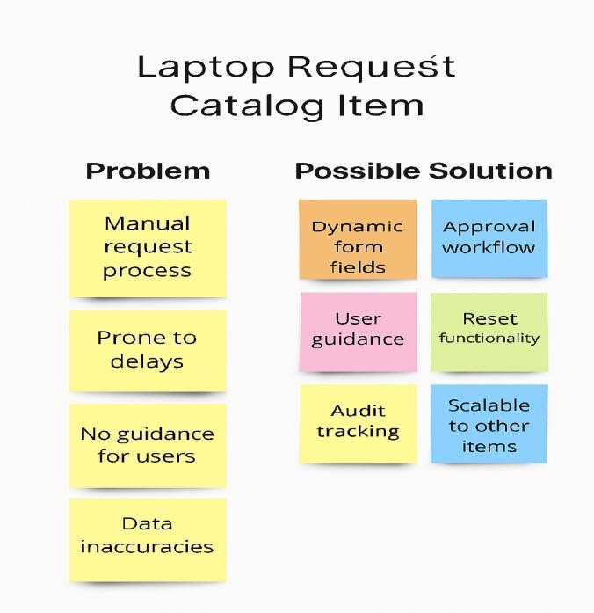

Step 2: Brainstorm, Idea Listing, and Grouping
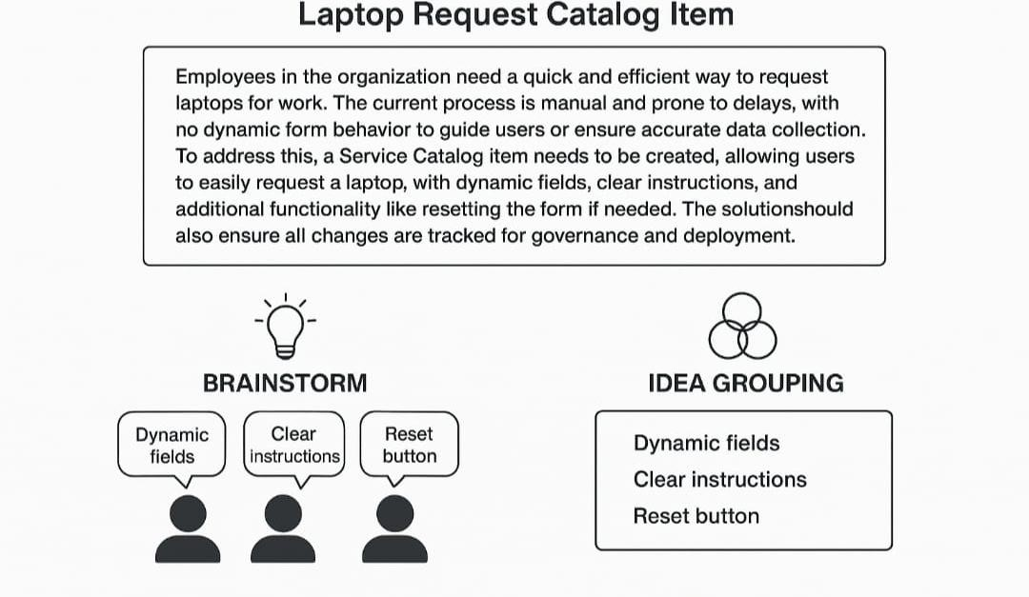

Brainstorm:
Each team member shared ideas on how to improve the laptop request process. Key suggestions included creating an automated form, adding reset and submit buttons, dynamic field visibility, and approval workflows.
Idea Listing:
All proposed ideas were documented — from including accessory options (like mouse or docking station) to integrating email notifications for approvals and deliveries.
Grouping:
Similar ideas were grouped under themes such as Form Design, Automation, and Approval Workflow. This helped identify which features could be implemented first and which required additional research or testing.
Action Planning:
- Form Design: Create fields for employee details, laptop type, and purpose.
- Automation: Add UI Policies to control field behaviour dynamically.
- Workflow: Route requests to manager and IT admin for approval. Step 3: Idea Prioritization
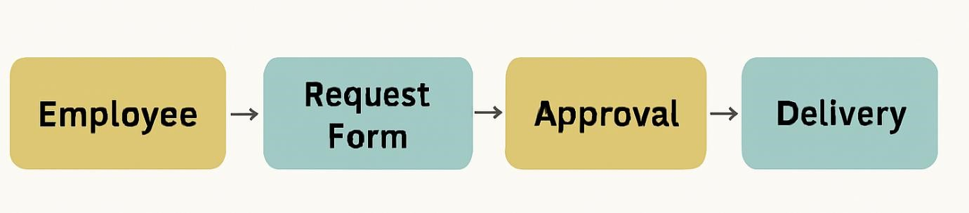
Idea Prioritization:

Idea prioritization helped the team break down the project into manageable and logical steps. The main focus was on building a functional Service Catalog Item that supports form customization and approval routing.
By prioritizing ideas, the team decided to:
- First, create the Laptop Request Form.
- Next, add UI Policies to show/hide fields dynamically.
- Then, implement UI Actions for submit and reset functionality.
- Finally, integrate the approval workflow and automate notifications.
This prioritization ensures clarity in execution, reduces confusion, and aligns with the project’s objective of enhancing service efficiency.
Using visual diagrams and workflow charts, the team was able to communicate the plan effectively and maintain a clear roadmap for development.
Overall, this phase provided a structured direction for creating an efficient, user-friendly, and automated Laptop Request Catalog Item that improves the employee IT service experience.

